CSO Lab 1:Electronic
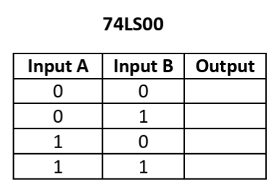
Switch the input according to the truth table below and complete the output column.
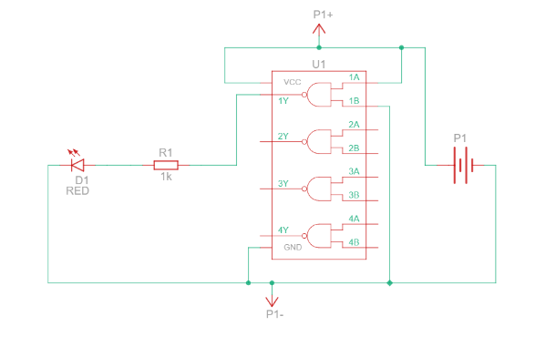
Q1:
Input: A=1, B=1 Output: 0
Input: A=0, B=0 Output: 1
Schematic diagram
1
1
1
0
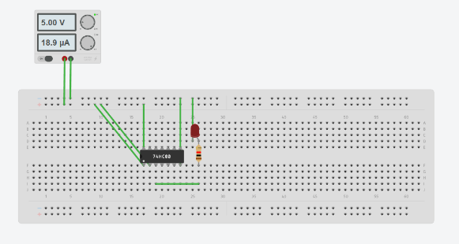
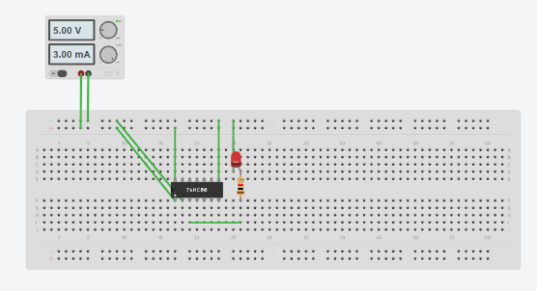
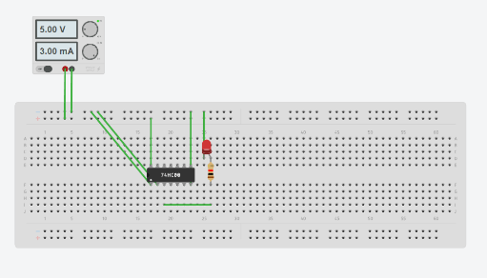
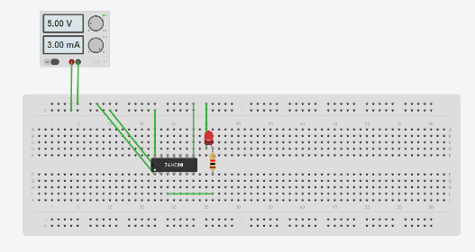
Input: A=1, B=0 Output: 1
Input: A=0, B=1 Output: 1

Q2:
Schematic diagram
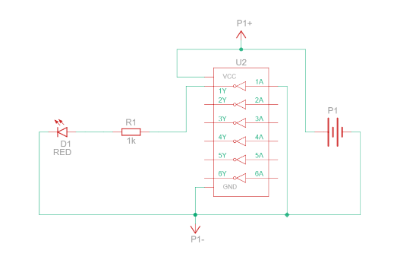
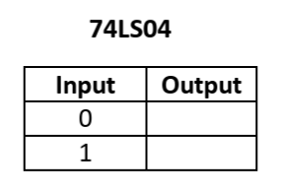
Input: A=1 Output: 0
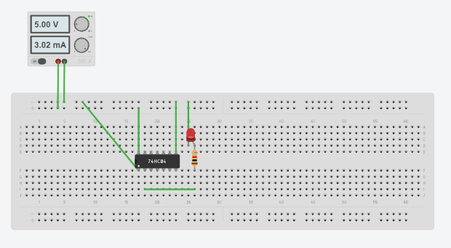
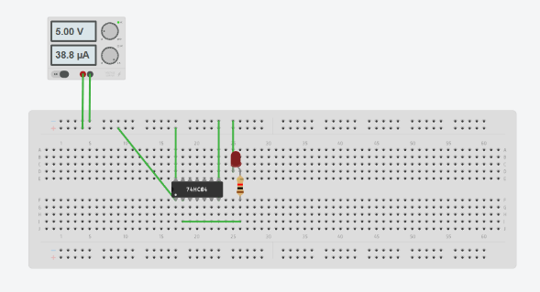
Input: A=0 Output: 1
1
0

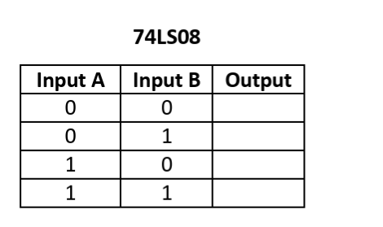
Q3:
Schematic diagram
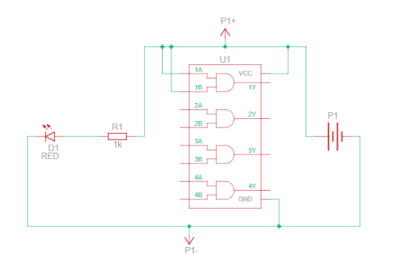
0
0
0
1

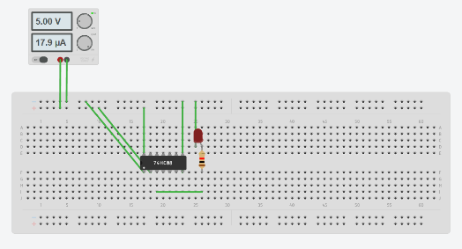
Input: A=0, B=1 Output: 0
Input: A=0, B=0 Output: 0
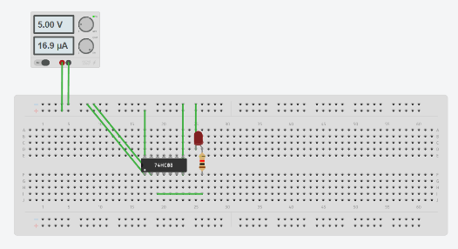

Input: A=1, B=1 Output: 1
Input: A=1, B=0 Output: 0
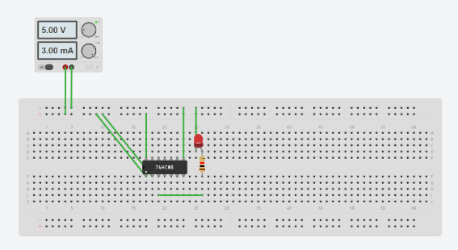
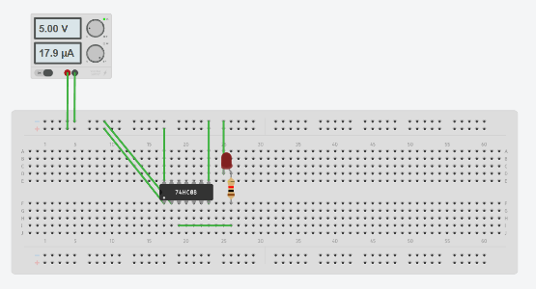

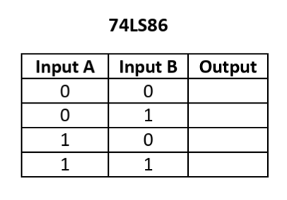
Q4:
Schematic diagram
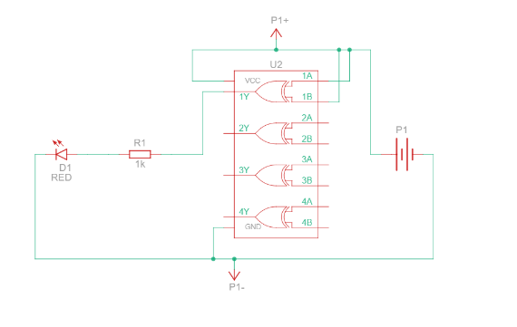
0
1
1
0

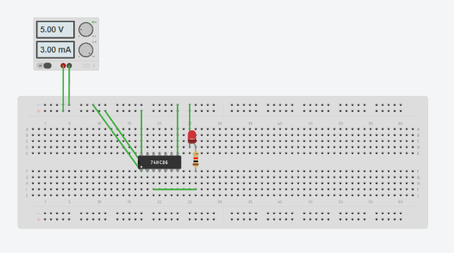
Input: A=0, B=1 Output: 1
Input: A=0, B=0 Output: 0
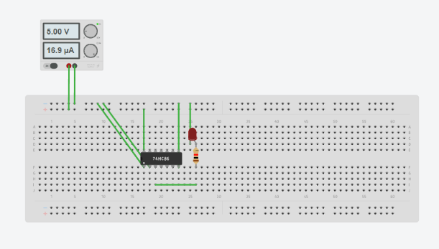

Input: A=1, B=1 Output: 0
Input: A=1, B=0 Output: 1
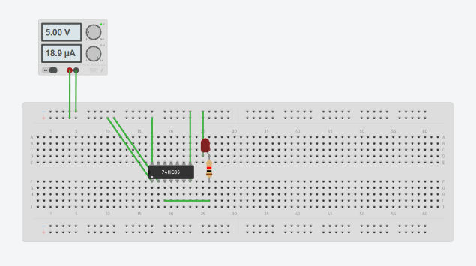
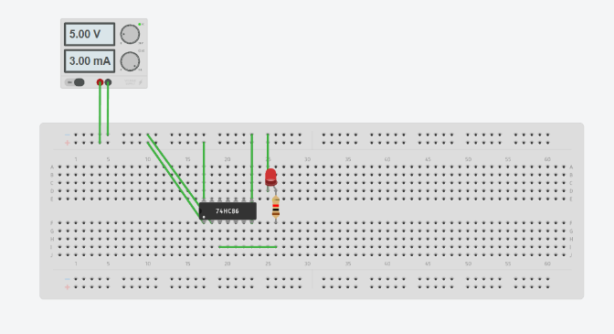

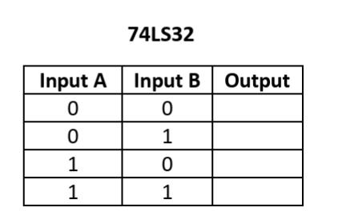
Q5:
Schematic diagram
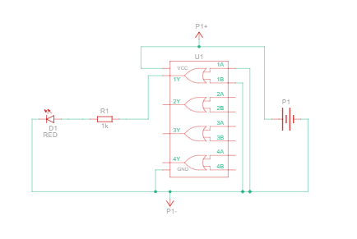
0
1
1
1

Input: A=0, B=1 Output: 1
Input: A=0, B=0 Output: 0
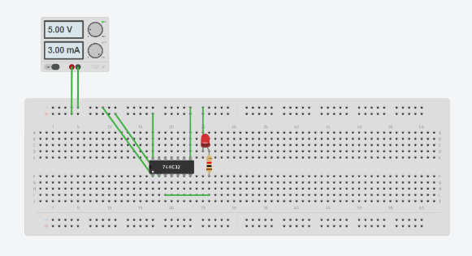
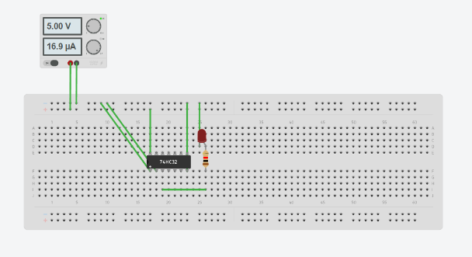

Input: A=1, B=1 Output: 1
Input: A=1, B=0 Output: 1
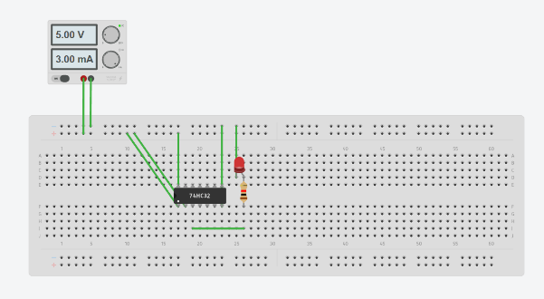
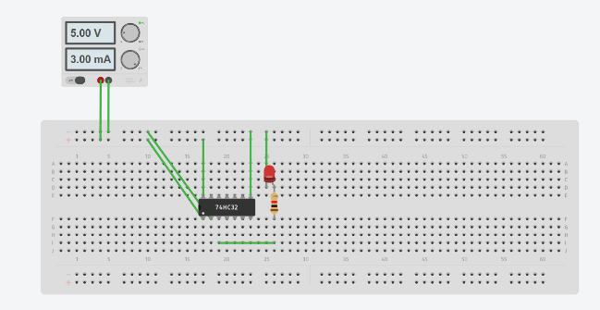

Result:
Based on the truth table value obtained by building a circuit, we can conclude that:
74LS00 is NAND gate
74LS04 is NOT gate
74LS08 is AND gate
74LS86 is XOR gate
74LS32 is OR gate

